Full Paper Title in Title Case
Name Surname, Name Surname
My Institute/Company
Address, City, Country
First.Author@institution.org; Second.Author@institution.org

ABSTRACT
In this paper, the formatting requirements for the International Conference on Computational Methods in Engineering & Health Sciences are described. Some recommendations on writing for a worldwide readership are offered. Please review this document to learn about the formatting of text, table captions, references, and the method to include the indexing information. The conference proceedings will be published in an electronic format only. The full paper in MS Word file shall be written in compliance with these instructions. At a later stage, it will be converted into Portable Document Format (PDF).An abstract not exceeding 300 words should appear on the top of the first page, after the title of the paper in a section titled "ABSTRACT" (without section number), after the names of the authors.
Keyword: - Journal paper, Product Design, Autodesk, Fusion 360 and ANSYS.

INTRODUCTION
It is expected that authors will submit carefully written and proofread material. Careful checking for spelling and grammatical errors should be performed. The number of pages of the paper should be from 5 to 8.
Papers should clearly describe the background of the subject, the authors work, including the methods used, results and concluding discussion on the importance of the work. Papers are to be prepared in English and SI units must be used. Technical terms should be explained unless they may be considered to be known to the conference community.

paper format
The uniform appearance will assist the reader to read paper of the proceedings. It is therefore suggested to authors to use the example of this file to construct their papers. This particular example uses an American letter format with 25 mm margins left, right, top and bottom.
All text paragraphs should be single spaced, with first line intended by 10 mm. Double spacing should only be used before and after headings and subheadings as shown in this example. Position and style of headings and subheadings should follow this example. No spaces should be placed between paragraphs.

Header, Footer, Page Numbering
Authors are asked to replace the "XXX" number (with the paper code that was assigned when the paper was accepted) on the header of the first page and on the footer of other pages in order to set a unique page number in the Proceedings.

Fonts
Papers should use 09-point Arial font. The styles available are bold, italic and underlined. It is recommended that text in figures should not smaller than 08-point Arial font size.

Tables and Figures
Figure captions and table headings should be sufficient to explain the figure or table without needing to refer to the text. Figures and tables not cited in the text should not be presented. The following is an example for Table 1.
Table 1 Title of the Table
Type of micro-particles | Average size (micro meter) | Variance (micro meter)
CuO | 47 | 4.2
NiO | 35 | 6.4
Tables and figures should be placed close after their first reference in the text. All figures and tables should be numbered with Arabic numerals. Table headings should be centred above the tables. Figure captions should be centred below the figures as shown in Figure 1.

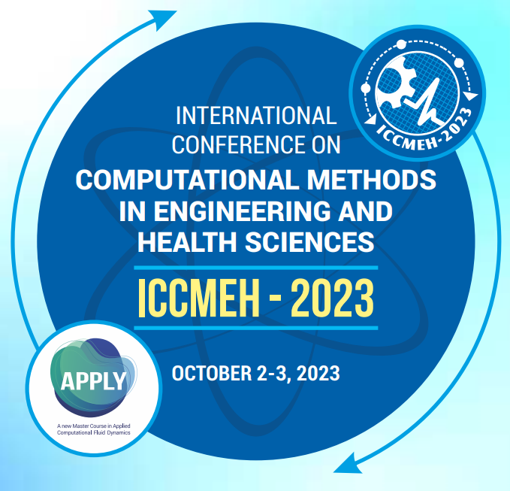
Figure 1: Conference tentative poster

Equations
Each equation should be presented on a separate line from the text with a blank space above and below. Equations should be clear and expressions used should be explained in the text. The equations should be numbered consecutively at the outer right margin, as shown in Eqs. (1) - (2) below. Here is one example.
In this case, the governing system of equations can be written as follows:
(1)
(2)

References
Proper references must be included throughout the text and the list of references must be provided in this section. The references inserted in the text and the list of references must be done as follow:
Reference citations: Citations in the main body, appendices, tables and figures are to be made using the last name of the author (both authors when only two; first author plus et al. when more than two). Example: "... as previously shown (Jones et al., 1989)," or "... as shown by Jones et al. (1989)." For two or more papers published in the same year by the same author(s), add a, b, c, etc. to the year such as (1980a) or (1980b) and cite jointly as Jones et al. (1980a, b).
List of references: List all cited references (including citations in tables, figures and appendices) in alphabetical order according to the first-named author. The titles of papers, patents and books or monograph chapters and the initial and final page numbers are to be included. Abbreviations of journal names should conform to the usage of Chemical Abstracts. Example for journal papers, book/monograph sections or chapters, and conference proceedings are given the reference section at the end of this document.

SUBMITTING THE Paper
The full paper has to be submitted electronically via the website of the conference (https://conference.manipal.edu/ICCMEH2023/). Paper number (in the format "XXX") is assigned to each abstract after it was accepted and authors are kindly asked to place the paper number to the correct positions in the header and footer before submitting the final version. The final paper file name should be the same name as for the accepted abstract (e.g. “XXX.doc”).

Conference Program and proceedings
The abstracts are compiled into the conference Proceedings and uploaded in the website page.

conclusion
Conclusions should state concisely the most important propositions of the paper as well as the author’s views of the practical implications of the results.

ACKNOWLEDGEMENTS
A short acknowledgement section can be written between the conclusion and the references. Sponsorship and financial support acknowledgments should be included here. Acknowledging the contributions of other colleagues who are not included in the authorship of this paper is also added in this section. If no acknowledgement is necessary, this section should not appear in the paper.

REFERENCES
References should be numbered using Arabic numerals followed by a period (.) as shown below and should follow the format in the below examples.
- P. P. Crown and L. Justin, The News Physics (Publisher Name, Publisher City, 2007), pp. 15–20.
- C. P. Grown and D. Arstin, Appl. Chem. Letters 84, 2501–2502 (2009).
- R. S. Lang, “Title of Chapter,” in Classic Physiques, edited by R. C. Tamil (Publisher Name, Publisher City, 1990), pp. 211–214.
- P. D. Dmith and E. C. Cones, “Load-cycling in cubic press,” in Shock Compression of Condensed Matter-2001, VIP Conference Proceedings 420, edited by M. F. Durnish et al. (VIP Publishing, Celville, NY, 2001), pp. 652–653.
- B. C. Backson and T. Ditman, U.S. Patent No. 3,345,224 (9 July 2005)
- D. D. Lavids, “Recovery effects in binary titanium alloys,” Ph.D. thesis, Hirvard University, 1998.
- R. R. Vikkylson (private communication).

