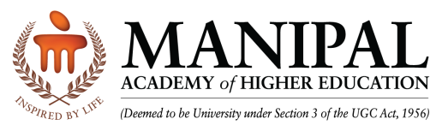
SEARCH – The KMC Health Sciences Library and
Dept. of Library & Information Science

4th National Conference on Management of Modern Libraries (NACML) – 2020

Reaching Out Users in the Digital Era: Opportunities and Challenges

January 10-11, 2020

Registration Form

Name (in CAPITAL letters) Dr./Mr./Ms./Mrs.: _________________________________________________

Designation: ______________________________________________________________

Institution/Organization: ______________________________________________________________

Address for Correspondence: ______________________________________________________________

______________________________________________________________

Contact Details: M: __________________________ e-Mail: __________________________

Presenting the Paper: Yes/No

Payment Details: Pay appropriate fee in favor of “Manipal Academy of Higher Education-Conference/Workshop”

Registration Fee:
- Delegates: ` 800.00
- Research Scholars, Students and Retired Professionals: ` 500.00

Payment Options: DD/NEFT/Cash

DD No.____________________ dated ____________________ Amount (Rs.) ______________ Drawn on

(Bank) _______________________________

Accommodation Required: Yes/No

Date: Signature

Wire Transfer Details
Beneficiary Name: Manipal Academy of Higher Education - Conference/Workshop
Bank Account Number: 33508958510
Name of the Bank: State Bank of India, Manipal
IFSC Code: SBIN0004426
MICR Code: 576002006
SWIFT Code: SBININBB770
Send duly filled up registration form along with the Demand Draft to: The Organizing Secretary, 4th NACML - 2020, KMC Health Sciences Library, Manipal Academy of Higher Education -576 104, Karnataka.

Details (softy copy or screen shot) of the online payment made (NEFT) should be sent to: lisconference@manipal.edu

